Forever 21

What we have done in this project

The first window that appears during run time asks the user whether he is a new user or an existing user. If he is an existing user, on clicking the button he will be taken to the existing user window where he can log into his account (the earlier window disappears). This will then be checked through the database connectivity whether he is an existing user or not. Now, if he is a new user he will be directed to the new user window where he can sign up by entering all the necessary details which gets stored in the database. If the email field and the confirm email field are not the same then a message box will display an error. Similarly, for the password field also, a message box showing an error will get displayed. If there are any empty fields within the form then another message box showing an error message will be displayed. On clicking login one can enter all the items and then generate a bill. You can only exit the application by clicking on the exit button as the cross button on top has been disabled.

Some Important steps

* To link one window with another

1, Create the two JFrames, let’s call them CustomerDetails.java and ExistingUser.java.

2, Drag a Button from the Pallete to CustomerDetails (in the GUI designer)

3, Select the Button and in the Properties window (on the right side of the screen by default, or using right-click menu of the Button) click on "Events".

4, Now, select the line with 'actionPerformed' and press the [...] button on

right side -> Handlers dialog should open

5, Add new Handler and name it as you wish (e.g. "openFrame"). Now hit OK and you will find yourself in source code of the CustomerDetails.java.

6, You should see a method called "openFrame", and you can edit it's body (the surrounding lines have grey background as they are not editable). Simply write there:

new SecondFrame().setVisible(true);

* To hide the window when another one appears

CustomerDetails.this.setVisible(false);

* To add a picture to the screen

1. Add a panel
2. Right click the panel in the navigator
3. Select set layout< null layout.
4. Add a label to the panel
5. Right click the label in the navigator
6. Select properties < Icon (….)
7. Select External Image < (….) button
8. Select location of file
9. Click on the open button< Ok< Close
10. Resize the label and the panel accordingly.

Clippings

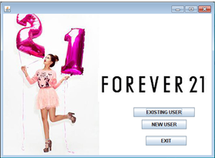

This is the first window that appears asking the user whether he is an existing user or a new user or he wants to exit.

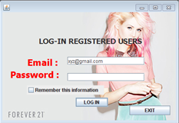

This is the window for existing customers to log in and check if he actually is an existing user or not.

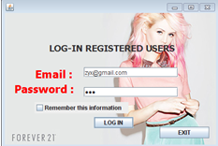 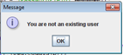

You can enter [xyz@gmail.com](mailto:xyz@gmail.com) in the email field and abc in the password field to check whether you are an existing user.

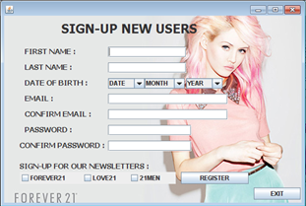

This is the window for new customers to register.

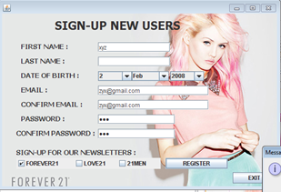 

You cannot leave any field empty and so a message will be displayed

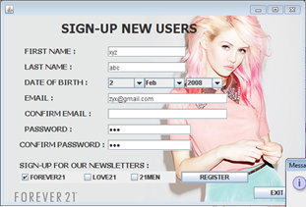 

The email fields need to be the same

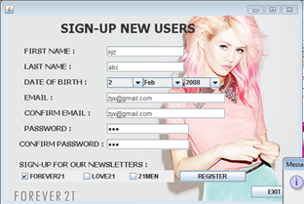 

The password fields also need to be the same

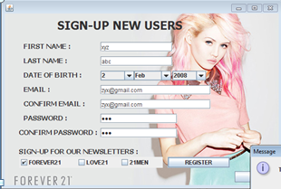 

A message appears when you sign up for the newsletters



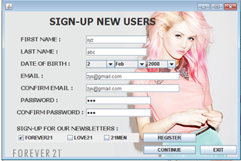

As soon as you register, another button appears for you to start shopping

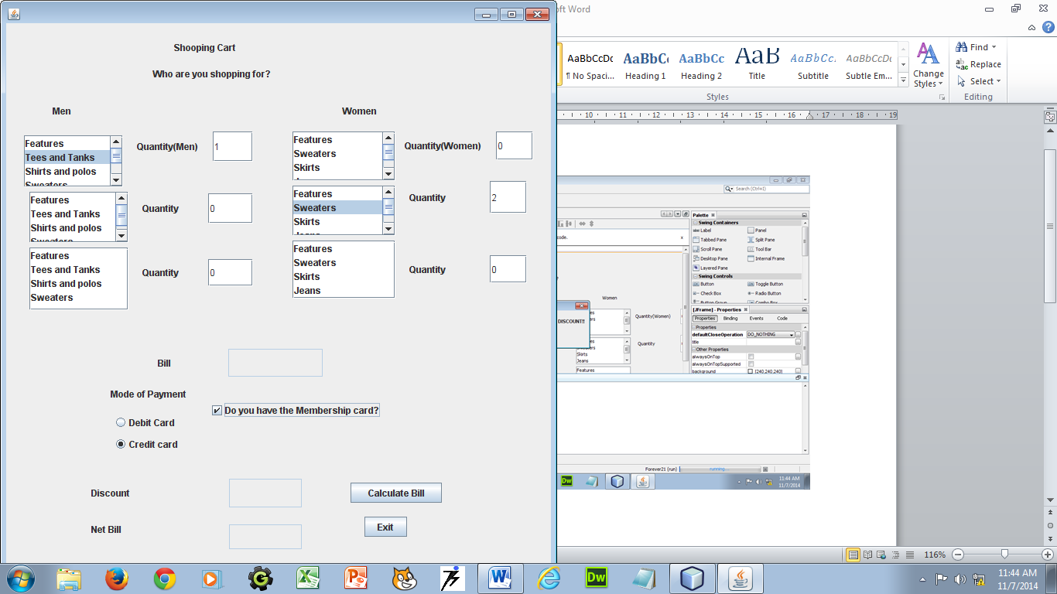

To shop

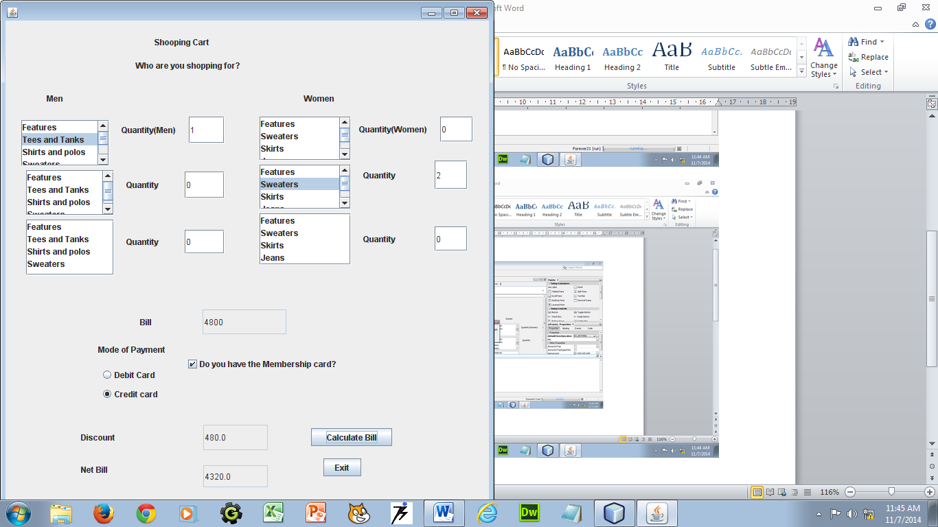

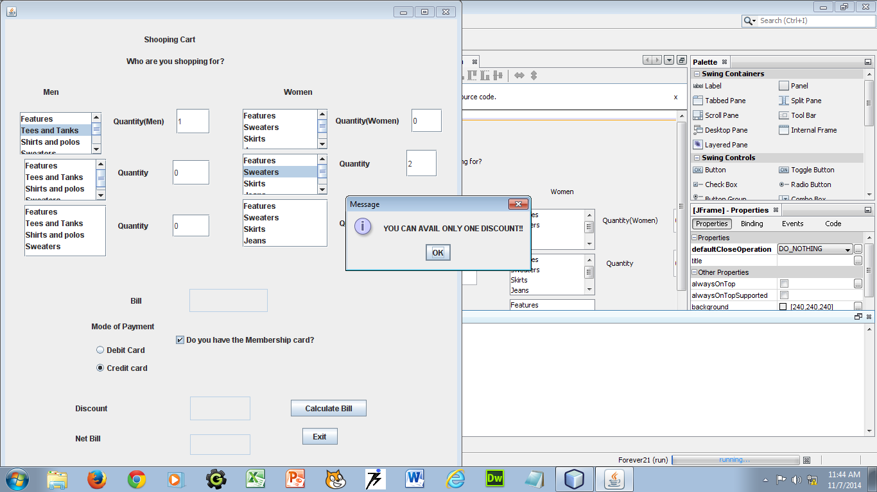 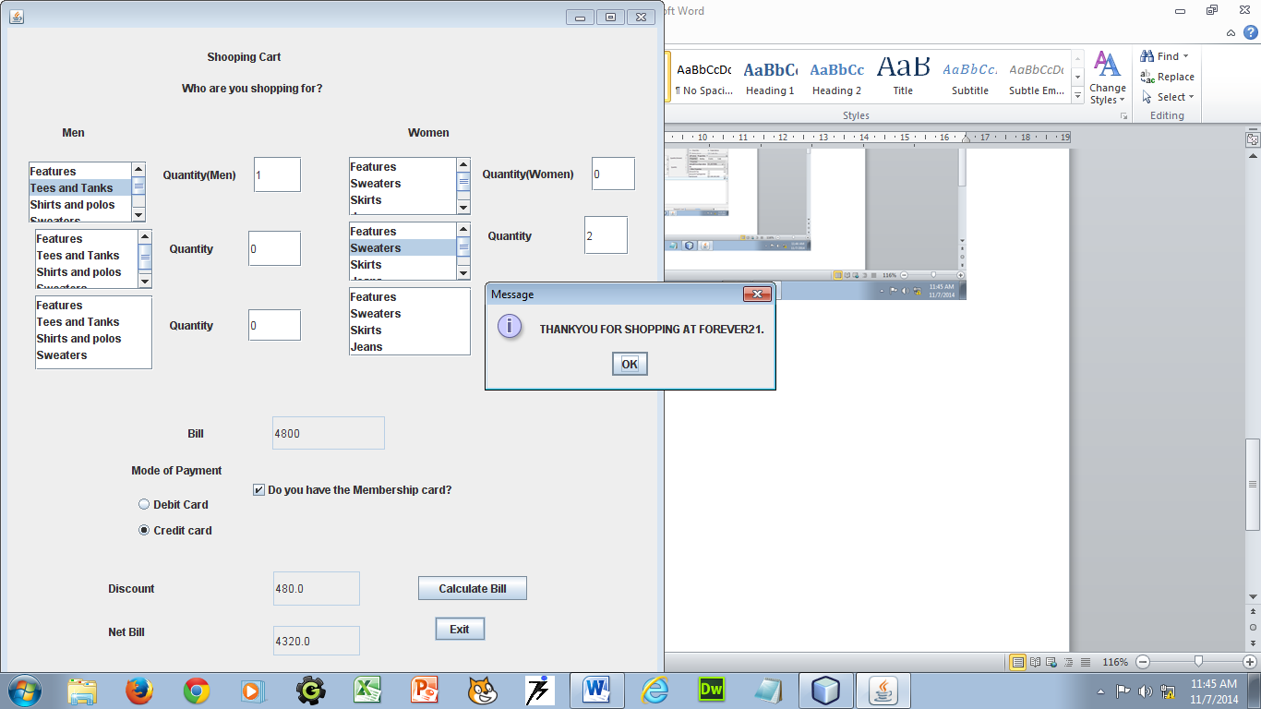

If you choose the checkbox then you will not get a discount

for the credit card or the debit card

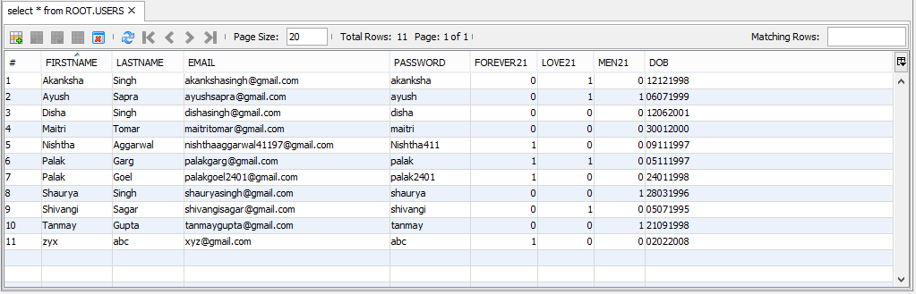

The table used for database connectivity to check for existing user or input the details of a new user.